**Why C programming?**

* C is a structured language which allows a complex program to be broken into simpler programs called functions.
* C language has a rich library which provides a number of built-in functions.



**To understand c programming language , you must know what are the compilation stages which any c code pass through them?**

**-source code is sent to compiler which compiles the code and many files produced from this operation.**

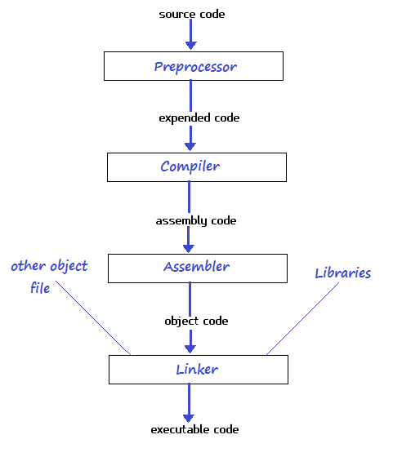

**What are Variables in c-programming?**

* Variable is a part from the memory, used to hold a piece of data.
* The variable has a type, name and value.
* The types of the variables differs in Size and/or Data to be saved.

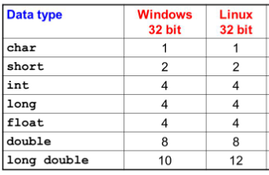

**Naming rules of variables**

* The first letter of a variable should be either a letter or an underscore.
* No Special Symbols other than underscore are allowed, ex ?, #, ….. etc
* Blanks & Commas are not allowed
* Variable name Should not be Reserved Word .
* Variable name can not be repeated in the same scope.
* A variable name can only have letters (both uppercase and lowercase letters), digits and underscore.

**Hello world program**



**Printf & scanf functions**

* printf() function can print a variable inside the string, it could be done by inserting format specifier that will be replaced by the values specified in subsequent additional arguments.



* scanf() function is used to read character, string, numeric data from user and save it in a variable.



**Exercise (1):**

* Write a C program to print the size of all primary data types in your compiler by using sizeof() function?



* Comments:
* Single-line comment

//this is the single line comment

* Multi-line comment
* /* hi,it’s a multi line

comment */

**What are c-programming operations?**

1. Arithmetic operations

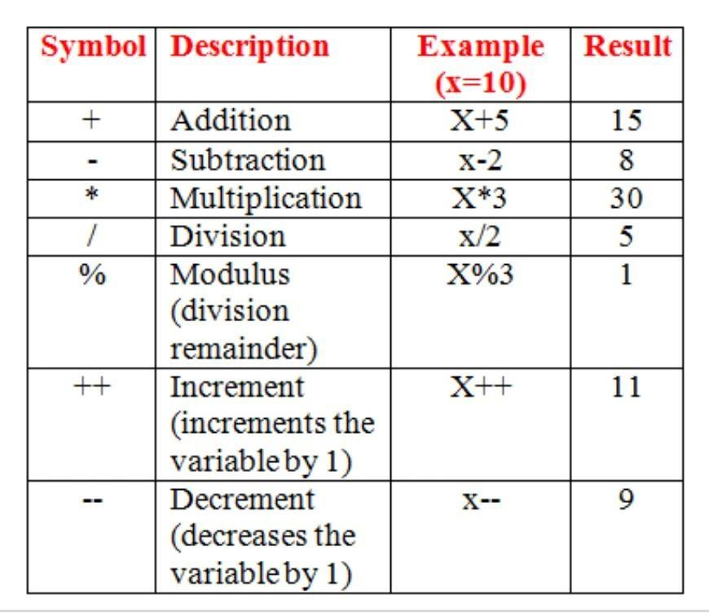

* **take care**

**difference between**



**Exercise 2:**

**math.h library**

* The **math.h** header defines various mathematical functions and one macro.